SILKTEST FUNCTIONAL TESTER (STFT) FRAMEWORK USER GUIDE
Version 1.0

Table of Contents
Preface 3
About this Guide 3
Audience 3
Document Conventions 3
Chapter 1 Introduction 4
1.1 Overview 4
Chapter 2 Installation of Framework 5
2.1 Installing the Framework 5
2.2 Importing Test Automation Framework Project 5
Chapter 3 Test Automation Methodology 7
3.1 Steps to Implement the Framework 7
3.2 Configure Other Application Related Files 10
Chapter 4 Guidelines 13

Preface

About this Guide

Audience
- Test Managers who are involved in implementation planning of a generic GUI test automation solution.
- Developers who will develop and implement the framework.
- Test Engineers who will adopt the framework to an application under test (AUT).

Document Conventions
The typographic and usage conventions of this guide are:
Bold | Headings of different chapters and sections.
Italic | Path used.

Chapter 1 Introduction

1.1 Overview
SilkTest is a GUI test automation tool with record and playback facility, but that seldom works consistently in automation projects. So, for scripting test cases, in the supported IDE, one needs to write a generic layer that supports the test scripts. The automation framework provides this generic, application independent layer, which provides code that would help developers to develop the test cases for their application under test (AUT) faster. The test automation framework is developed for SilkTest 10.1
Currently, the framework consists of following major areas/features:
- Utility Functions on different verification and validations area form the core area of the automation framework.
- Logging utility, which provides .txt logging and smart logging (High level) rich test report generation.
- Recovery System recovers AUT from unexpected events and continues test execution.
- Mechanism to handle the situation where test case does not continue to execute if primary test case on which it depends is failed.
- Mechanism to capture screenshot for failed test cases.
- Data driven approach is implemented for the Test cases where multiple data sets can be used. Data input is given using XLS sheet to Test cases.

Chapter 2 Installation of Framework

Installing the Framework
Following steps to be followed in order to install the Framework:
- Unzip the file Quicken.zip to any of the installation directory or
- If you have perforce then get the latest code from perforce repository (//qa/SilkTestQD/Quicken_2011/) to user defined installation directory (e.g. Quicken folder created under D:\ drive)
- Make sure that the read and write permissions are given to the base directory and all the sub directories and files residing in those folders.

2.2 Importing Test Automation Framework Project
To use the Automation framework it is necessary to import/open the project file in SilkTest. Following steps would help to open the project which is unzipped in the base directory.
1. Open SilkTest.
2. Go to File menu and select Open Project.
3. The “Open Project” dialog box opens, go to base directory where framework has installed.
4. Select the project file located in base directory (e.g. D:\Quicken\FrameworkSpecific\STFTFramework) i.e. STFTFramework.vtp
5. Click on Open button. This will load the project.
6. Run the Option Set file “quickendesktopoptionset.opt” located under <Installation Directory>\ApplicationSpecific\Includes\. This would perform the necessary environment settings, agent settings required for automation.

2.1.2 Verifying Automation Project Skeleton
Snapshot of directory structure in Windows explorer
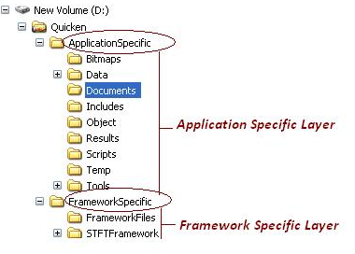

Snapshot of directory structure in SilkTest

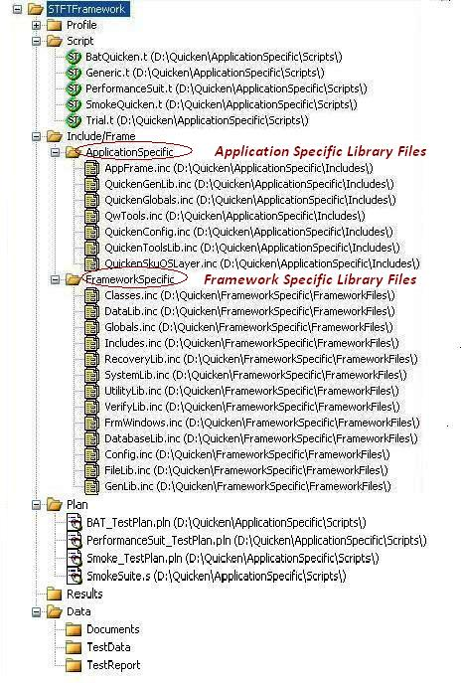

Chapter 3 Test Automation Methodology

3.1 Steps to Implement the Framework
Creating Application Specific Layer-
- Set Recovery System
- Creating Windows declarations for GUI objects
- Creating Application specific library functions
- Creating test cases
Open SilkTest to execute the following procedure:

3.1.1 Set Recovery System
Recovery System for an AUT can be set using following steps:
- Run Application Under Test
- Go to File menu, Click on New
- Select ‘Frame’ option from the given options provided by SilkTest
- Select AUT from the list of active applications
- Click on OK button
- Go to file menu and save the file with name AppFrame.inc in “...\Quicken\ApplicationSpecific\Includes” folder.

    - Creating Windows declaration for GUI objects
Add all the window declarations for GUI objects on AUT in an .inc file under “...\Automation\ApplicationSpecific\Includes” folder.
Following is a sample generation of AppFrame.inc file.
- Open AppFrame.inc file, the declarations will be appended to this file.
- Select Record/Window Declarations.
- Make your application active and invoke one of its dialogs/windows, to be recorded. If necessary, arrange windows so that you can see the target dialog/window and the ‘Record Window Declarations’ dialog of SilkTest.
- Press Ctrl+Alt. The declaration is frozen and shown in the window ‘Record Window Declarations’.
- In the Record Window Declarations dialog, click Paste to Editor.
- Close the target dialog.
- Repeat from step no. 2 to 6 for all the target dialog boxes for windows declaration.
- Include the path of this file in ‘Includes.inc’ file which is present under Framework Specific files “...\Quicken \FrameworkSpecific\Includes.inc” by using statement ‘use ...\Quicken\ApplicationSpecific\AppFrame.inc’.
- Include the Includes.inc file which is present under “...\Quicken\FrameworkSpecific” folder in your Test Cases which are present under “...\Quicken\ApplicationSpecific\Scripts” folder by using use statement (i.e. ‘use ...\Quicken\FrameworkSpecific\Includes.inc’). Include.inc loads all the libraries and gui declaration files used by automation.

3.1.3 Creating Application specific library functions
Application specific library functions are nothing but the common code which one has to write for performing different logical steps in AUT. This can be related to the business logic or functionality of AUT. The steps to create library functions are -
- Identify the common libraries to develop, which can form smallest blocks of code in testing different functionalities in the AUT.
- Create separate Include file (.inc) for different functionalities or areas of testing in AUT.
- Implement the common libraries by scripting methods in those files.
- Ensure that the functions you develop in classes of this layer are common and generic (although specific to application under test) enough so that they can be used across multiple test cases of an AUT.
- Save this file as ‘QuickenGenLib.inc’ in “...\Quicken\ApplicationSpecific” folder and add it to ‘Includes.inc’ file in “...\Quicken\FrameworkSpecific” folder.

3.1.4 Creating test cases –
Follow below guidelines to create the test cases.
- Create an empty 4Test Script file (.t) Right-click on “ApplicationSpecific\Scripts” directory and select ‘New File...
- Write test cases and Test case Id should contain the purpose in 2 or 3 words (e.g. Test03_AddCheckingAccount which tells that this test case will add checking account).

Snapshot of Test Cases stored in SilkTest

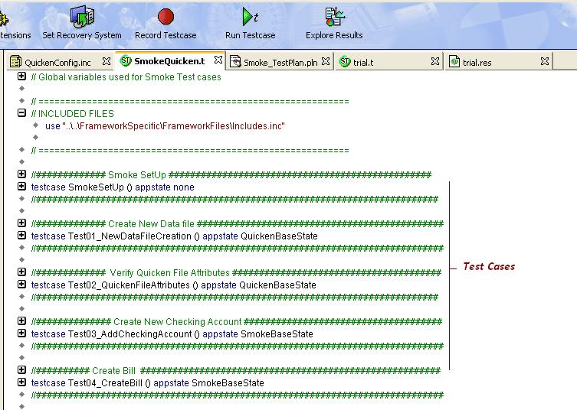

3.2 Configure Other Application Related Files
Config File
- Store all the machine specific information in different variables:
  - OPERATING_SYSTEM - Get OS name
  - COMPUTER_NAME - Get Computer name
  - PROGRAMFILES - Get Location of Program Files
  - USERNAME - Get User name
  - ALLUSERSPROFILE - Get Location of All User Profiles folder
  - USERPROFILE - Get Location of User Profile folder
  - OS_BIT - Get the bit of OS(i.e. 32 bit or 64 bit)

- Save this file as ‘QuickenConfig.inc’ in “...\Quicken\ApplicationSpecific\Includes” folder and add this .inc file to ‘Includes.inc’ file in “...\Quicken\FrameworkSpecific” folder.

OS/SKU compatible layer
- Write a function which will identify the OS and perform the necessary actions. For e.g. Location of ‘All User Profile’ folder is different in Windows XP and Windows 7 or Windows Vista.
- Write a function which will identify the Quicken SKU and will load appropriate data file as well as variables for verification.
Save this file as ‘QuickenOSLayer.inc’ in “...\Quicken\ApplicationSpecific\Includes” folder and add this .inc file to ‘Includes.inc’ file in “...\Quicken\FrameworkSpecific” folder.

This file is useful in running automation suite on multiple OS and SKUs.

Global Variables Declaration
- Right click on ApplicationSpecific folder and select “Add New File”.
- Declare all application related Global Variables in this file and save the file as ‘QuickenGlobals.inc’.
- A dialog box will be displayed which will ask for adding this file in the Project, click on OK button.
- Add this Inc file in ‘Includes.inc’ file in “...\Quicken\FrameworkSpecific” folder.

Other Utilities
- Right click on ApplicationSpecific folder and select “Add New File”.
- Select Record/Window Declarations.
- Make other Utilities window (e.g. QwAuto, Intuonl etc) active in order to be recorded and window declarations can be seen in ‘Record Window Declarations’ dialog of SilkTest.
- Press Ctrl+Alt. The declaration is frozen and shown in the window ‘Record Window Declarations’.
- In the Record Window Declarations dialog, click Paste to Editor.
- Close the target dialog.
- Repeat from step no. 2 to 6 for all the utility windows.
- Save this file as ‘QwTools.inc’.
- A dialog box will be displayed which will ask for adding this file in the Project, click on OK button.
- Include the path of this file in ‘Includes.inc’ file which is present under Framework Specific files “...\Quicken \FrameworkSpecific\Includes.inc” by using statement ‘use ...\Quicken\ApplicationSpecific\QwTools.inc’.

Chapter 4 Guidelines
Refer following coding guidelines document for Quicken Desktop Automation



